Chapter 8 Testing
Link to GitHub and Path for Chapter 8 Folder
https://github.com/jocooper317/SDEV153-WebPage.git
https://github.com/jocooper317/SDEV153-WebPage/tree/677e3fc777b8c723571eefc766999d634d0d3d91/Ch8

Testing Verifications –
Chapter 8 CSS W3C Validation –
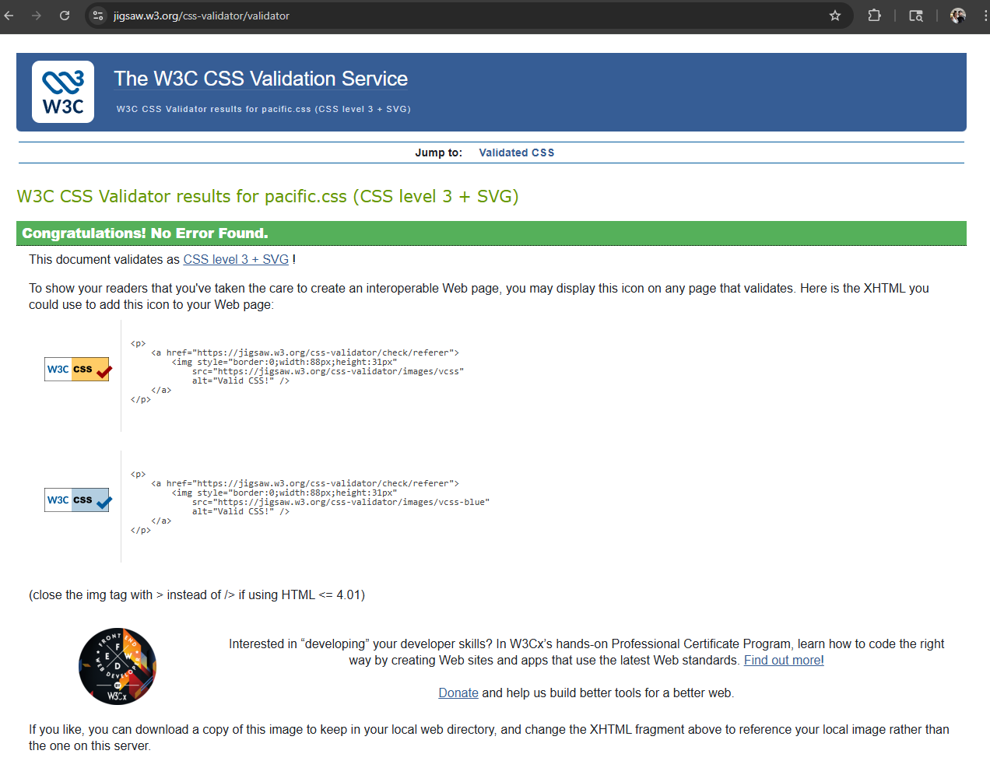
Chapter 8 Yurts.html html validation –
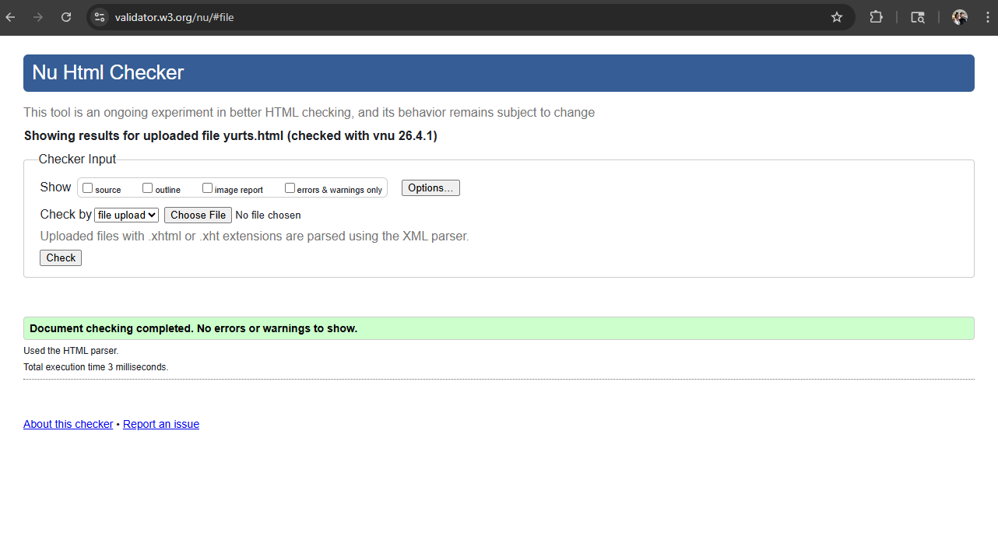
Yurts.html testing –
